**4.Git-HOL**

**Create a new branch GitWork and switch to it**

* **git checkout -b GitWork**

**Add a file hello.xml and update its content**

* **echo "<message>Hello from GitWork branch</message>" > hello.xml**

**Stage and commit the file**

* **git add hello.xml**
* **git commit -m "Added hello.xml from GitWork branch"**

**Switch back to master**

* **git checkout master**

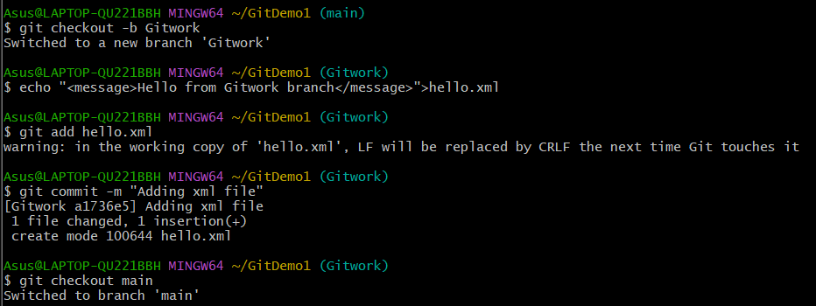**Add a different version of hello.xml in master**

* **echo "<message>Hello from master branch</message>" > hello.xml**

**Commit changes in master**

* **git add hello.xml**
* **git commit -m "Added hello.xml from master branch"**

**View logs in graph format**

* **git log --oneline --graph --decorate –all**

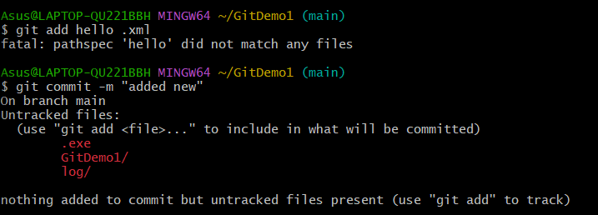

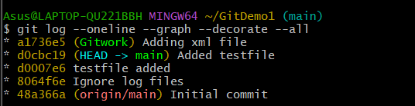

**Check differences using CLI tool**

* **git diff master GitWork**

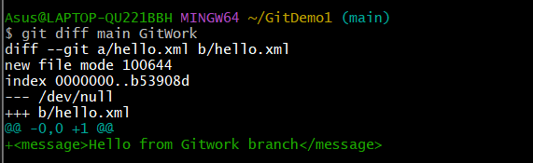

**Merge GitWork into master**

* **git merge GitWork**

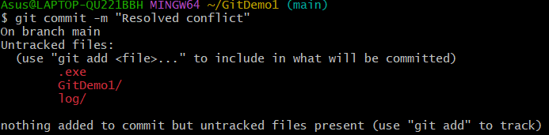

**Commit after resolving conflict**

* **git add hello.xml**
* **git commit -m "Resolved merge conflict in hello.xml"**

